STD I TO STD VIII START THE NEW ACADEMIC YEAR,
2020-2021

Dear Parents,
Welcome to the Academic year, 2020-2021 ! We are all creating history as all of us without exception are into Virtual Learning :)
We are having a lot of fun trying to get things right with lots and lots of virtual meetings, to decide what to do virtually :)
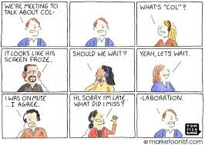
Am feeling very sorry for the kids, they never knew when the academic year was over, when they had vacations and now we tell them it's time for the next academic year :)
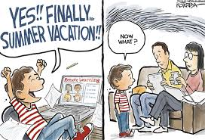
We have already started classes for the Seniors and our teachers have been working very-very hard. Now it's time for us to start classes from the 18th of June, 2020, for the Juniors :)
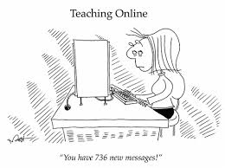
We do not want kids of Std I to Std VIII to be time bound, so for them, lessons will be uploaded in Google Classroom with the follow up work. Parents can please sit with them to their convenience and guide them through the lessons. We have planned for classes in English & Maths every day. This apart in all the other subjects we will have 2 classes per week. In Computers, we will have only 1 class per week. Lessons for a week will be sent together. Answers may also be sent through Google classroom for teachers to correct and return. We also do not want children to be staring at the monitor for a long time, so parents have the option of teaching the children all or any of the subjects they can. Lessons can be taught from the text and answers can be written in the notebooks. To maintain uniformity, even teachers will be setting work only on the exercises given at the end of every lesson in the text. However, for every concept one creative question will be set which will encourage children to think and arrive at a solution, this will be in addition to what is given in the text. In brief, virtual lessons will be sent to all and parents have to decide whether they want the child to study virtually or they would teach the lessons to the child with the hardcopies of the texts and notebooks, so that the Computer can be avoided, as much as possible. The paths taken may be different but the goal must be the same. The goal is that every child must be healthy physically, mentally, emotionally, socially and spiritually. INFACT, THE SCHOOL INVITES SUGGESTIONS FROM PARENTS REGARDING ANY OTHER WAY OF HAVING REGULAR LESSONS FOR CHILDREN.
The Heads and a few teachers will have virtual interaction with all the children in small groups, as often as possible. These will be live and you can join your child for those 15 to 20 minutes. Details for these meetings will be sent subsequently. Arrangements will be such that you just have to click,'Join meeting' in the 'Invitations' that will be sent for these. Tomorrow, the Heads will be sending the portions that will be covered in June & July, 2020, as a separate mail. Email IDs and mobile numbers of teachers who will be handling the child's class will also be sent as another mail.
We have given below details about 'Google Classroom' that has been put together by our teacher, Ms Arumugapriya. We are sure you will find the details very useful.

Looking forward to travel a new path with all of you :)
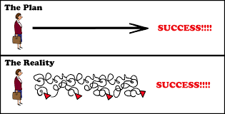
Be safe, take care and stay in touch.
God bless.
Nirmala
8th June, 2020

TOGETHER WE CAN DO IT :)
