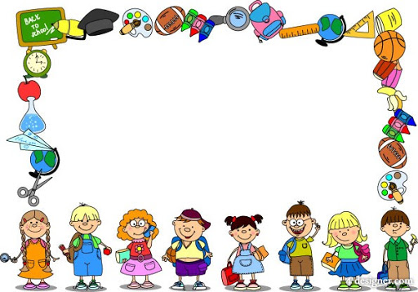

Dear Parent,

It has been just over a month since we started sending lessons through Google Classroom. Both teachers and parents have been working very hard and of course, our kids have been working very-very hard, so hard that we felt that it's time for a well deserved change of routine :)
Jeevana has always believed in activity oriented education & individual attention, both of which are difficult to organise now. We do not want to give up so easily and so thought we will utilise this break of two weeks to address these activities.
We will be sending you videos on Yoga, Dance Exercise, Meditation, Sports, Art, Craft, Songs, Dances, Value Education, Soft Skills and interesting aspects of studying Physics, Chemistry, Biology, History, Geography, Mathematics and
very-very interesting ways of developing skills in English. Hope all of you find these enjoyable and useful.
Education is not about only studying Textbooks and we all agree on this. It is about helping the child become a
well-rounded individual. Hope the next two weeks contribute towards this.
Hope children try out all the activities suggested, identify their interests and most important, enjoy them :)

Stay safe.
Take care.
Nirmala

